**Lab 03**

**Objectives:**

This lab will enable students to:

* + Learn top down and bottom up design methodologies
  + Use seven segment display available on the S3board
  + Data flow level modeling

**TASK:**

**BCD to Seven Segment Decoder**

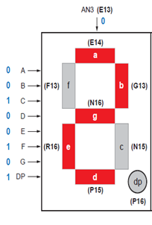**Block Diagram:**

**I/O Connections:** your module will have 4 bit input and 8 bit output. Connect input to switches and output to seven segment display.

**Description:**

In this task you are required to take a BCD input from the user and display that number on the seven segment display. Following diagram shows the 7 bit code for displaying “2” on the seven segment display all the input are active low signals. Note that enable signal should be held low in order to turn on the particular seven segment display. There are 4 seven segment displays on the S3BOARD. In later labs you will learn how to use time multiplexing techniques to turn on all the four seven segment displays as the input A,B,C,D,E,F,G, Dp are shared by all the four seven segment displays.

**Steps:**

1. Using switches enter a BCD number and show the resulting number on the seven segment display.
2. Connect the output of your lab assignment 1 S0-S4 to the seven segment display. Note that number above 1001 are not valid BCD numbers. In this situation keep the seven segment display off and just the dp on.